
COMSATS University Islamabad
Abbottabad, Pakistan

Patchy- Skin Cancer Localization

By

Wania Khan CIIT/SP21-BCS-050/ATD
Eman Waheed CIIT/SP21-BSE-007/ATD
Bushra Gul CIIT/SP21-BSE-070/ATD

Supervisor
Dr.Nuhman ul Haq

Bachelor of Science in Computer Science (2020-2024)

The candidate confirms that the work submitted is their own and appropriate
credit has been given where reference has been made to the work of others.
COMSATS University, Islamabad Pakistan

Patchy- Skin Cancer Localization

A project presented to
COMSATS Institute of Information Technology, Islamabad

In partial fulfillment
of the requirement for the degree of

Bachelor of Science in Computer Science (2020-2024)

By

Wania Khan CIIT/SP21-BCS-050/ATD
Eman Waheed CIIT/SP21-BSE-007/ATD
Bushra Gul CIIT/SP21-BSE-070/ATD

DECLARATION
We hereby declare that this software, neither whole nor as a part has been copied out from any source. It is further declared that we have developed this software and accompanied report entirely on the basis of our personal efforts. If any part of this project is proved to be copied out from any source or found to be reproduction of some other. We will stand by the consequences. No Portion of the work presented has been submitted of any application for any other degree or qualification of this or any other university or institute of learning.

Wania Khan Eman Waheed

--------------------------- ---------------------------
Bushra Gul

---------------------------
CERTIFICATE OF APPROVAL
It is to certify that the final year project of BS (CS) “Patchy-Skin Cancer Localization” was developed by Wania Khan (CIIT/SP21-BCS-050/ATD), Eman Waheed (CIIT/SP21-BSE-007/ATD) and Bushra Gul (CIIT/SP21-BSE-070/ATD) under the supervision of “Dr Nohman ul Haq ” and co supervisor “CO-SUPERVISOR NAME” and that in (their/his/her) opinion; it is fully adequate, in scope and quality for the degree of Bachelors of Science in Computer Sciences.

---------------------------------------
Supervisor

---------------------------------------
External Examiner

---------------------------------------
Head of Department
(Department of Computer Science)

EXECUTIVE SUMMARY
The project's goal is to create an advanced system for skin cancer monitoring and diagnosis. Modern technology will improve patient care and diagnostic accuracy by connecting with medical record systems.
With the use of advanced artificial intelligence models, this creative solution will analyze skin photos and provide accurate localization and diagnosis of lesions. It will make patient record maintenance easier and allow for thorough tracking of lesion progression over time. Additionally, the system will have a mobile application that will give medical practitioners flexible, mobile access to vital information and reports.
Importantly, the system will not provide precise treatment recommendations or replace medical competence; rather, it will assist and improve clinical decision-making. Licensed experts will continue to have the last say on diagnosis and treatments.

Overall, this project is set to transform skin cancer diagnostics and patient management by combining cutting-edge technology with robust data integration, ultimately aiming for improved patient outcomes and streamlined clinical processes.

ACKNOWLEDGEMENT
First and foremost, we express our utmost gratitude to Almighty Allah, who’s boundless
Knowledge and blessings have enabled us to accomplish this challenging endeavor.
We would like to extend our sincere appreciation to our project supervisor, Dr.Nuhman ul Haq,
whose invaluable guidance, personal supervision, and insightful advice have been instrumental
in the successful completion of this project. Without their unwavering support and mentorship,
This accomplishment would have been uncertain. We are truly grateful for their encouragement
and constant assistance throughout this endeavor.
We would also like to express our heartfelt thanks to our parents and family members for their
unending encouragement, unwavering support, and belief in our abilities. Their love, motivation, and values of honesty and hard work have been a constant source of inspiration for us.
Furthermore, we would like to extend our gratitude to all the teachers and faculty members
who have contributed to our academic journey, imparting knowledge, and shaping our
understanding.
Finally, we acknowledge the contribution of all the researchers and authors whose
work and publications have provided us with the necessary insights and foundation for our
project.
Once again, we express our deepest gratitude to everyone who has been a part of this project,
directly or indirectly and has played a role in its successful completion.

Wania Khan Eman Waheed

--------------------------- ---------------------------
Bushra Gul

---------------------------
ABBREVIATIONS
SRS | Software Require Specification
PC | Personal Computer
SDD | Software Design Document
PRE | Pre-Condition
API | Application Programming Interface
SDLC | Software Development Life Cycle
FR | Functional Requirement
OOP | Object Oriented Programming
CNN | Convolutional Neural Networking

Table of Content
1. Introduction 11
1.1. Brief 11
1.3. Project Background 13
1.4. Literature Review 13
1.5. Analysis from Literature Review (in the context of your project) 14
1.6. Methodology and Software Lifecycle for This Project 14
1.6.1. Rationale behind Selected Methodology 15
2. Problem Definition 15
2.1. Problem Statement 15
3. Requirement Analysis 17
3.1. Use Cases Diagram(s) 17
3.2. Detailed Use Case 18
3.3. Functional Requirements 26
3.4. Non-Functional Requirements 28
4. Design and Architecture 30
4.1. System Architecture 30
5. Implementation 30
5.1. User Interface 35
6. Testing 37
6.1. Manual Testing 37
6.1.1. System testing 37
6.1.2. Unit Testing 37
6.1.3. Functional Testing 39
6.1.4. Integration Testing 40
6.2. Automated Testing: 41
7. Conclusion and Future Work 42
7.1. Future Work 42
8. References 43

List of Figures

Figure 3.1: Use Case Diagram 17
Figure 4.1 System Architecture Diagram 30
Figure 4.2 Process Flow Representation 31
Figure 4.3 Sequence Diagram 32

List of Tables
Table 3.1 Register Use Case 18
Table 3.2 Login Use Case 19
Table 3.3 Upload Image Use Case 19
Table 3.4 Manage Account Use Case 21
Table 3.5 View Image History Use Case 22
Table 3.6 Generate Report Use Case 23
Table 3.7 Check Medical History Use Case 24
Table 3.8 Account Information Use Case 25
Table 3.9 Lesion Detection and Localization 26
Table 3.10 Professionals 26
Table 3.11 Integration with AI- base Models 27
Table 3.12 Mobile Application Interface 28
Figure 4.1 System Architecture Diagram 30
Figure 4.2 Process Flow Representation 31
Figure 4.3 System Sequence Diagram 32
Table 5.1: Details of APIs used in the project 35
Table 6.1: Upload Image Test case 37
Table 6.2: Generate Report Unit Testcase 38
Table 6.3: Direct Messaging Unit Testcase 38
Table 6.4: Upload Image Functional Testcase 39
Table 6.5: Generate Report Functional Testcase 39
Table 6.6: Direct Messaging Functional Testcase 40
Table 6.7: Integration Testcase 40
Table 6.8: Tools used 41

- Introduction
One of the most common types of cancer in the world is skin cancer, and patient outcomes and effective treatment depend heavily on early identification and accurate diagnosis. A major obstacle in dermatology is the intricacy of correctly diagnosing and tracking skin lesions. Our initiative is concentrated on creating an integrated system that will transform the diagnosis and treatment of skin cancer to address this.
This advanced system combines cutting-edge artificial intelligence with seamless integration into medical record systems, aiming to give healthcare workers strong tools for better patient care and diagnostic accuracy. With the use of an intuitive mobile application and AI-based models for lesion recognition and analysis, the system will enable real-time monitoring, accurate lesion location, and thorough tracking of lesion progression.
Our strategy focuses a strong emphasis on improving clinical workflows and decision-making procedures while making sure that technology enhances rather than replaces the knowledge of qualified medical practitioners. Our goal with this system is to provide a game-changing solution that enhances diagnostic accuracy while facilitating efficient patient care and patient management.

  - Brief
The purpose of this project is to create a sophisticated, integrated system for managing and detecting skin cancer. Utilizing artificial intelligence and convolutional neural networks (CNNs). Technology seeks to precisely identify and locate skin lesions by using CNNs to analyze and categorize skin images. In the end, better patient care and clinical decision-making will result from the integration of CNN-based analysis with patient record systems, which will improve diagnosis accuracy and facilitate efficient tracking of lesion growth.
  - Relevance to Course Modules
This project aligns closely with the core subjects covered during my Bachelor of Computer Science (BSE) program, including:
- Data Science (DS): We studied different techniques in this course, such as model training, data cleaning, deep learning, neural networks, and learned different algorithms which we used in our project.
- Artificial Intelligence (AI): With the help of this course, we learned how to make a machine intelligent. It helped us in choosing the best model and we also learned about supervised and unsupervised learning. Since we trained the model using a labelled dataset, we used supervised learning.
- Mobile App Development: Through this mobile app development course, students are introduced to the basics of creating mobile applications. We learn about app structure, design, and interactions with the device's operating system. Additionally, students gain foundational programming knowledge for mobile environments. By using frameworks like React Native or Flutter, they practice building apps for different platforms. As a result, students develop skills to design, develop, and deploy mobile applications effectively. This knowledge is especially useful during the project's development phase, providing a solid foundation for mobile app development.
- Human Computer Interaction (HCI): With the help of this course, we learned the importance of UI design and the mistakes that can lead to an unattractive interface and the failure of the system. It helped us in building a user-friendly and more interactive interface.
- Database Systems: This course helped us learn the fundamental ideas and uses of database systems, the fundamentals of SQL, how to build SQL queries, and the fundamentals of relational database design. We needed to build a database for our project; therefore, this course was helpful.
- Software Project Management: With the help of this course, we learned how to apply project management concepts and techniques to our project. This course helped us break down the whole development phase into different iterations (WBS) to manage the whole project effectively. This course helped us make Gantt charts.
- Introduction to Software Engineering: With the help of this course, we learned about the different phases of the software development lifecycle. This course made us able to choose the best software engineering model. We selected the Agile model for our project because we needed to make changes in our requirements and designing interface time by time. This course also helped us in making different diagrams that were required in SRS, SDD, and presentations.
- Software Requirement Engineering: With the help of this course, we learned how to gather different requirements, analyze them, and use them effectively.
- Software Quality Engineering: With the help of this course, we learned how to deliver a quality product that satisfies the customer's requirements and fulfils for which it is development.

  - Project Background
Skin cancer is still a major health concern worldwide, and better patient outcomes and effective treatment depend on early detection. Conventional approaches to skin cancer diagnosis mostly rely on visual inspections and biopsy techniques, which can be laborious and variable depending on the experience of the physician performing the process.
The goal of this project is to improve the accuracy and efficacy of skin cancer diagnosis by utilizing the capabilities of convolutional neural networks, or CNNs. Because CNNs are a type of deep learning algorithms that can automatically learn and recognize patterns and features from big datasets, they have shown to be quite successful in image analysis applications. The method attempts to provide accurate skin lesion detection and localization by applying CNNs to skin pictures, categorizing them as either benign or malignant. Accurate tracking of changes in the patient's condition will be made possible by integrating this AI-driven method with patient record systems, which will enable thorough monitoring of lesion growth over time. This connection gives medical professionals comprehensive, data-driven insights that not only increase diagnostic accuracy but also improve patient management.
In general, the initiative aims to improve patient care by streamlining clinical workflows, lowering diagnostic mistakes, and modernizing skin cancer diagnosis with new technologies.

  - Literature Review
Convolutional Neural Networks (CNNs) have been used more and more in dermatology recently to improve skin cancer diagnosis. AI is being used in current products like MoleScope, SkinVision, and DermAI to evaluate skin lesions and follow changes, indicating a move toward real-time monitoring and diagnosis powered by AI. Research also highlights certain difficulties, such as the requirement for a variety of training datasets in order to reduce bias and enhance the generalizability of models. The integration of artificial intelligence (AI) with mobile applications and electronic health records (EHRs) highlights the potential of AI to revolutionize dermatological treatment by reflecting an increasing trend towards enhanced clinical processes and comprehensive patient management.

1.5. Analysis from Literature Review (in the context of your project)
Convolutional neural networks (CNNs) are being used in our project to identify skin cancer, and the literature evaluation highlights several important trends and findings. Based on products like DermAI and SkinVision, current research and products show that CNNs have a great deal of promise to achieve high diagnosis accuracy for skin lesions. These techniques demonstrate a technical trend towards automated AI-driven diagnostics by using sophisticated AI to classify and evaluate lesions.
By employing CNNs to identify and locate skin lesions, our effort contributes to these developments by improving diagnostic accuracy. But our study also tackles important issues that have been brought up in literature, like the requirement for representative and diverse training datasets to assure model generalizability and fight biases. In contrast to certain other tools that might not be as diverse in their datasets, our approach takes into account a wide range of skin tones and lesion kinds to increase accuracy across various patient populations.
Additionally, a crucial element of our research is the integration of AI with mobile applications. Our approach attempts to improve both by integrating CNN-based lesion analysis with patient record systems and offering a mobile interface for real-time access.
In conclusion, while previous studies and products demonstrate the effectiveness and guarantee of artificial intelligence (AI) in dermatology, our project expands on these findings by addressing acknowledged constraints like dataset diversity and providing integrated solutions that combine cutting-edge AI with useful tools for better patient care.

1.6. Methodology and Software Lifecycle for This Project
The Object-Oriented Programming (OOP) design style is used for this project, which focuses on the early identification of skin cancer using Convolutional Neural Networks (CNNs) and combines with medical therapies. Because of its focus on modularity, reusability, and maintainability—all of which are essential for creating complex systems that combine several components, such AI models, medical data, and mobile applications—OOP is especially well-suited for this project. Moreover, The Agile SDLC model is selected for this project due to its iterative and incremental approach, which aligns well with the need for continuous improvement and adaptation in medical applications.

    - Rationale behind Selected Methodology
The requirement for a reliable, flexible, and user-centered system for the diagnosis and treatment of skin cancer led to the choice of Object-Oriented Programming (OOP) and the Agile Software Development Lifecycle (SDLC) paradigm for this project. Because of its benefits in modularity, reusability, and maintainability—all of which are essential for building a sophisticated system with CNN models, integration of medical records, and a mobile application interface—OOP was selected. OOP makes system management, upgrades, and scalability easier by encapsulating functionalities into modular objects. Because of its modular design, the system may easily include new features and modifications while keeping up with advances in medical technology. In addition to OOP, the Agile SDLC model offers an incremental and iterative methodology that is perfect for addressing the dynamic nature of medical software development, Agile places a strong emphasis on collaboration among stakeholders, flexibility, and iterative improvement to make sure the system can quickly adjust to changing requirements and consider user feedback. This iterative method improves the efficacy and usefulness of the system while also bringing the project into compliance with clinical requirements and user needs. When combined, OOP and Agile offer a thorough framework that facilitates the creation of a complex, flexible, and user-centered skin cancer detection system.

- Problem Definition
This chapter discusses the precise problem to be solved. It should extend to include the outcome. Accurate tracking of growth is challenging in current skin cancer detection methods because they lack comprehensive spatial information on lesions. Due to a lack of training data, they frequently display bias towards lighter skin tones, which causes under-detection in people with darker complexion. Furthermore, these systems typically don't provide thorough reporting or patient record integration. The goal of this project is to create a system that offers enhanced patient data management, automatic size tracking, and accurate lesion localization.

  - Problem Statement
To trace the growth of a lesion, current skin cancer detection technologies frequently only provide spatial parameters like exact position and size, instead of focusing on classifying lesions as benign or malignant. Lesion size tracking by hand is difficult and susceptible to bias. Furthermore, due to a lack of training data, many systems are biased towards lighter skin tones, which results in an under-detection of skin cancer in people with darker skin tones and hair. Effective patient analysis and treatment are further hampered by the incapacity of current systems to track patient history and generate comprehensive reports based on imaging data. In order to close these gaps, an integrated system that enables full patient record management, automatic size tracking, precise lesion location, and bias reduction is being developed.
  - Deliverable and Development Requirements
The project deliverables include:
- Mobile Application Prototype: Development of a mobile application prototype for Skin Cancer detection.
- Trained Machine Learning Model: Implementation and training of a machine learning model for analyzing images to detect Skin Cancer indicators.
- Server Deployment: Deployment of backend server infrastructure to host the machine learning model and handle image analysis requests.
- Documentation: Preparation of comprehensive documentation covering the mobile app architecture, machine learning model specifications, deployment procedures, and user guides.
- Testing and Validation Reports: Conducting thorough testing of the mobile application and machine learning model, and documenting validation reports to ensure accuracy and reliability.
Development requirements involve:
- Data Collection and Cleaning: Proficiency in collecting and cleaning data relevant to Skin Cancer detection, ensuring quality and accuracy for model training.
- Machine Learning Model Training: Expertise in training machine learning models, specifically convolutional neural networks (CNNs), for image analysis.
- Server Infrastructure: Knowledge of setting up and maintaining server infrastructure to support the deployed machine learning model and handle user requests.
- Application Development: Skills in mobile app development, particularly using frameworks like Flutter, for creating intuitive user interfaces and integrating backend services.
- Integration and Testing: Experience in integrating various components of the system (mobile app, backend server, machine learning model) and conducting rigorous testing to ensure functionality and performance.
- Completion of a thesis detailing the project's objectives, methodology, findings, and conclusions.
- Requirement Analysis

  - Use Cases Diagram(s)

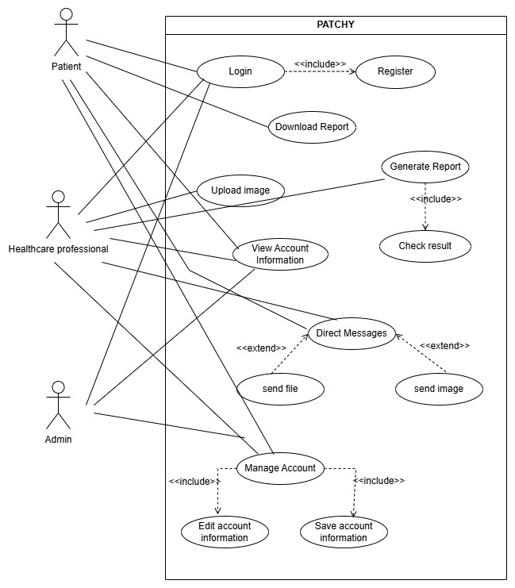

Figure 3.1: Use Case Diagram
  - Detailed Use Case
Table 3.1 Register Use Case
Use Case ID: | . UC-1
Use-Case Name: | Register
Actors: | Primary Actor: Patient, Healthcare professional(users)  Secondary Actor: Admin
Description: | A User registers an account, providing personal details, including health conditions and environmental conditions
Trigger: | The User indicates the intention to register a new account.
Preconditions: | PRE-1: User is not logged into the system.
Post  conditions: | POST-1: User account is successfully created.  POST-2: User is logged into the system.
Normal Flow: | User selects the option to register a new account.  System prompts the User to enter personal details, health conditions, and environmental conditions.  User provides the required information.  The system validates the entered information.  System creates a new account for the User.  System logs the User into the newly created account.
Alternative Flows: | [Alternative Flow 1 - Invalid Information]  If the provided information fails validation checks or contains errors, the system displays an error message indicating the specific fields that need to be corrected. The actor is prompted to review and correct the invalid information. The flow continues from Step 4.  [Alternative Flow 2 – Existing Account]  If the provided information matches an existing account in the system,  The system displays an error message indicating that an account with the  provided details already exists
Exceptions: | None
Business Rules | BR-1: User registration requires valid personal details.  BR-2: User must agree to the terms and conditions.
Assumptions: | ASSUMPTION-1: Users have a valid email address for account verification.

Table 3.2 Login Use Case
Use Case ID: | . UC-2
Use-Case Name: | Login
Actors: | Primary Actor: Patient, Healthcare professional (users)  Secondary Actor: Admin
Description: | A User logs into the system using their credentials.
Trigger: | The User indicates the intention to register a new account.
Preconditions: | PRE-1: User is not already logged into the system.
Post  conditions: | POST-1: User is successfully logged into the system.
Normal Flow: | Users enter their username and password.  The system validates the entered credentials.  If the credentials are valid, the system logs the User into their account.  If the credentials are invalid, the system notifies the User and stops the process.
Alternative Flows: | [Alternative Flow 1 - Invalid Credentials]  If the entered credentials are invalid (e.g., incorrect username or password), the system displays an error message. The actor is prompted to re-enter the correct credentials or perform a password recovery/reset if necessary. The flow continues from Step 2.
Exceptions: | E1: If the entered credentials are invalid, the system notifies the User and stops the process.
Business Rules | BR-1: Users must enter valid credentials for login.
Assumptions: | ASSUMPTION-1: Users have already registered an account.

Table 3.3 Upload Image Use Case
Use Case ID: | UC-3
Use Case Name: | Upload Image
Actors: | Primary Actor: Patient, Healthcare professional  Secondary Actor: Admin
Description: | A User uploads images to the system for skin cancer detection.
Trigger: | The User indicates the intention to upload image for disease detection.
Preconditions: | PRE-1: User is logged into the system.  PRE-2: User has passed the eligibility test.  PRE-3: User has navigated to the section for uploading images.
Post  conditions: | POST-1: Image is successfully uploaded.  POST-2: The system performs cancer detection on the uploaded image.
Normal Flow: | User selects the option to upload image  User uploads the image.  The system validates the image format and quality.  The system performs cancer detection on the uploaded image.  System classifies the results into healthy or unhealthy categories.  System provides a response indicating the Skin cancer status.
Alternative Flows: | [Alternative Flow 1: Invalid Image Format or Quality]  If the image format is unsupported or the quality does not meet the system’s standards (e.g., too blurry or low resolution), the system displays an error message.  [Alternative Flow 2: Image Upload Failure]  If there is an issue with the upload process (e.g., network failure or file corruption), the system displays an error. If successful, proceed to step 3 of the Normal Flow.
Exceptions: | None
Business Rules | BR-1: The system will not detect images with high-quality resolution.
Assumptions: | ASSUMPTION-1: Users have access to a device with a camera or pre-existing images.

Table 3.4 Manage Account Use Case
Use Case ID: | . UC-5
Use-Case Name: | Manage Account
Actors: | Primary Actor: Patient, Healthcare professional  Secondary Actor: Admin
Description: | Users update their account information.
Trigger: | Users indicate a desire to update their profile.
Preconditions: | PRE-1: User is logged into the system.
Post  conditions: | POST-1: User’s account information is successfully updated in the skin cancer detection system.
Normal Flow: | User selects the option to Manage the account.  System prompts users to edit information.  Users make changes and saves.  System updates the account.
Alternative Flows: | [Alternative Flow 1: User Cancels the Update]  The system discards any modifications made during the session and returns the user to the previous screen without saving changes.  [Alternative Flow 2: Validation Errors]  If the input fails validation (e.g., invalid format, missing required fields), the system displays error messages specifying the issues. Repeat the process again.
Exceptions: | E1: If the system is temporarily unavailable (e.g., due to maintenance or a network outage), the user cannot update their account information.  E2: If the user does not have the necessary permission to update certain account details (e.g., restricted fields), the system prevents the update.
Business Rules | B1: The system must ensure that all required fields are filled out correctly and meet validation criteria before saving any updates.
Assumptions: | ASSUMPTION-1: Users are aware of their account details and required fields that need updating.

Table 3.5 View Image History Use Case
Use Case ID | UC-6
Use-Case Name: | View Image History
Actors: | Primary Actor: Patient, Healthcare Professional
Description: | A Patient accesses the Picture Archiving to view the history of images for a specific patient. This includes selecting the patient and viewing all stored images and associated reports.
Trigger: | A Patient indicates that they want to view a patient's image history.
Preconditions: | PRE-1. User is logged into System  PRE-2. Users have the necessary permissions to view patient images.
Post  conditions: | POST-1. The patient's image history is displayed  POST-2. The user can review images and associated reports.
Normal Flow: | User logs into PACS  The system displays the dashboard.  User selects a patient.  The system displays the patient's image history.  User views the images and associated reports.
Alternative Flows: | [Alternative Flow 1: Not in Network]  The system displays a message indicating that network connectivity is required to access patient image history.
Exceptions: | E1: No Images Available  E2: System informs User that no images are available for the selected patient.
Business Rules | B1: Only authorized personnel can view patient images.  B2: Images must be stored securely and comply with data protection regulations.
Assumptions: | ASSUMPTION 1: 30 percent of Users will view image history for a patient at least once a week (Source: previous 6 months of System data).

Table 3.6 Generate Report Use Case
Use Case ID | UC-7
Use Case Name: | Generate Report
Actors: | Primary Actor: Healthcare Professional
Description: | Healthcare Professional accesses the System to generate a report on patient data. The user selects the criteria for the report, such as date range, type of report, and specific patient details. The system compiles the data and generates the report, which can then be viewed, or saved by the user.
Trigger: | Healthcare Professional indicates that they want to generate a report.
Preconditions: | PRE-1. User is logged into System  PRE-2. User has the necessary permissions to generate reports
Post conditions: | POST-1. The report is generated and stored in System  POST-2. The report can be viewed or saved by the user.
Normal Flow: | User requests to generate a report  The system displays report criteria options (e.g., date range, type of report).  User selects the desired criteria.  The system compiles the data based on the selected criteria.  System generates the report.  User views the report.  User chooses to save the report.
Alternative Flows: | [Alternative Flow 1: Specify Report Format]  The user selects the desired criteria and specifies the report format (e.g., PDF, Excel).
Exceptions: | E1: If User cancels the report generation, then System terminates the use case.  E2: Else if User selects a new date range, then System restarts the use case
Business Rules | B1: Only authorized personnel can generate and view sensitive patient data reports.
Assumptions: | ASSUMPTION 1: 20 percent of Users generate at least one report per week.

Table 3.7 Check Medical History Use Case
Use CaseID | UC-8
Use Case Name: | Check Medical History
Actors: | Secondary Actor: Healthcare Professional
Description: | Healthcare Professional accesses the System to view a patient's medical history.
Trigger: | Healthcare Professional indicates that they want to check a patient's medical history.
Preconditions: | PRE-1. User is logged into System.  PRE-2. Users have been granted access to view the medical history.
Post conditions: | POST-1. The patient's medical history is displayed.  POST-2. The user can navigate through different sections of medical history.
Normal Flow: | User logs into System  The system displays the dashboard.  User navigates to the medical history section.  The system displays the patient's medical history.  User views medical history.
Alternative Flows: | [Alternative Flow 1: Not in Network]  The system displays a message indicating that network connectivity is required to access patient medical history.
Exceptions: | E1: No Medical History Available  E2: System informs User that no medical history is available
Business Rules | B1: Medical history can only be viewed by the patient or authorized personnel.  B2: Patients can only download their medical history if they have completed identity verification.
Assumptions: | ASSUMPTION 1: 50 percent of Users check their medical history at least once a month.

Table 3.8 Account Information Use Case
Use Case ID | UC-9
Use Case Name: | Account Information
Actors: | Primary Actor: Patient, Healthcare professional  Secondary Actor: Admin
Description: | User accesses the System to view or update their account information. This includes personal details, contact information, and security settings. The user can also review account activity
Trigger: | A User indicates that they want to view or update their account information.
Preconditions: | PRE-1. User is logged into System  PRE-2. Users have the necessary permissions to view patient images.
Post  conditions: | POST-1. The user's account information is updated and saved.  POST-2. The user receives confirmation of any changes made.
Normal Flow: | User logs into System.  The system displays the dashboard.  User navigates to the account information section.  The system displays the current account information.  Users update their account information.  The system saves updated information.  The system confirms the updates to the User.
Alternative Flows: | [Alternative Flow 1 Change password]  Change Password  Users choose to change their password.  System prompts for the current password and the new password.  Users enter the required information.  The system validates and updates the password.  Return to step 6 of normal flow.
Exceptions: | E1: Invalid Information Provided System informs User that the information provided is invalid.  E2: If the User cancels the update process, then System terminates the use case
Business Rules | B1: Users must provide valid identification for significant account changes (e.g., changing contact details)
Assumptions: | ASSUMPTION 1: 75 percent of Users will review their account information at least once every six months.
  - Functional Requirements
      - Lesion Detection and Localization:
      - Patient Record Management
      - Integration with AI-based Models
      - Mobile Application Interface

Functional Requirement 001
Table 3.10 Lesion Detection and Localization
Identifier | 1
Requirement ID | FR-001
Title | Lesion Detection and Localization
Requirement | system perspective:  The system shall accurately detect and localize skin lesions in images, pinpoint the exact location, and analyze lesion size automatically to aid in monitoring and tracking potential growth over time.
Source | System
Rationale | To ensure accurate diagnosis, examination, and monitoring of skin conditions for better patient outcomes.
Business Rule (if required) | Must comply with medical imaging standards and be compatible with various image formats.
Dependencies | None
Priority | High

Functional Requirement 002
Table 3.11 Professionals
Identifier | 2
Requirement ID | FR-002
Title | Professionals
Requirement | system perspective:  The system shall allow healthcare professionals to input and manage patient records, track patient history using image data, and generate customizable reports based on patient data and lesion analysis.
Source | Electronic Health Record (EHR) Systems, Health Informatics Standards
Rationale | To improve patient care through organized records, historical tracking, and detailed reporting.
Business Rule (if required) | Must comply with patient data privacy regulations
Dependencies | None
Priority | High

Functional Requirement 003
Table 3.12 Integration with AI- base Models
Identifier | 3
Requirement ID | FR-003
Title | Integration with AI-based Models
Requirement | system perspective:  The system shall integrate AI-based deep learning models for lesion detection and classification, utilize datasets like HAM10000 to train models, and improve lesion segmentation accuracy.
Source | Development team
Rationale | To enhance diagnostic accuracy and efficiency using advanced AI technologies.
Business Rule (if required) | Must ensure AI models meet performance and safety standards.
Dependencies | None
Priority | High

Functional Requirement 004
Table 3.13 Mobile Application Interface
Identifier | 4
Requirement ID | FR-004
Title | Mobile Application Interface
Requirement | system perspective:  The system should have a user-friendly mobile application interface, allow professionals to use the mobile app for lesion identification and analysis on-the-go, and provide easy access to patient records and reports.
Source | User (Patient)
Rationale | To offer flexibility and convenience for healthcare professionals in various settings.
Business Rule (if required) | Must be compatible with major mobile platforms (iOS, Android).
Dependencies | FR-002
Priority | Medium
  - Non-Functional Requirements
- Accuracy and Reliability
Definition: Accuracy and reliability requirements focus on the precision and dependability of the system's outputs to ensure it functions correctly and provides trustworthy results.
AR-1: The system shall achieve an accuracy rate of at least 95% for lesion detection and classification, minimizing false positives and false negatives to ensure reliable diagnosis.
AR-2: The system shall maintain a false positive rate of less than 2% and a false negative rate of less than 1% in lesion detection to reduce the likelihood of misdiagnosis.
- Performance
Definition: Performance requirements ensure that the system operates efficiently, providing results in a timely manner and handling the necessary workload immediately.
PER-1: The system shall process and analyse each skin image within 5 seconds to provide timely results for lesion detection.
- Security
Definition: Security requirements focus on protecting sensitive data, ensuring that only authorized users can access or modify patient information, and complying with relevant regulations.
SEC-1: The system shall encrypt all patient data in transit and at rest using industry-standard encryption protocols to ensure data security and privacy.
SEC-2: The system shall implement role-based access control (RBAC) to restrict access to patient records and analysis results to authorized healthcare professionals only.
- Scalability
Definition: Scalability requirements ensure that the system can grow and handle increasing amounts of work or users without compromising performance or functionality.
SCA-1: The system shall be able to scale to support a database of up to 10,000 patient records without performance degradation.
SCA-2: The system shall be capable of handling up to 1,000 simultaneous user requests without sacrificing performance or response time.
- Usability
Definition: Usability requirements focus on the ease of use and accessibility of the system, ensuring that healthcare professionals with different levels of technical expertise can use it effectively.
USE-1: The system shall allow healthcare professionals to capture and upload an image of a skin lesion with no more than three interactions (clicks/taps).
USE-2: The system shall provide clear, step-by-step instructions and visual aids for capturing and uploading images to assist users with varying levels of technical expertise.
USE-3: The system shall feature an intuitive user interface designed according to UX/UI best practices to ensure a smooth and efficient user experience for healthcare professionals.

- Design and Architecture
The following parts of Software Design Description (SDD) report should be included in this chapter.

  - System Architecture

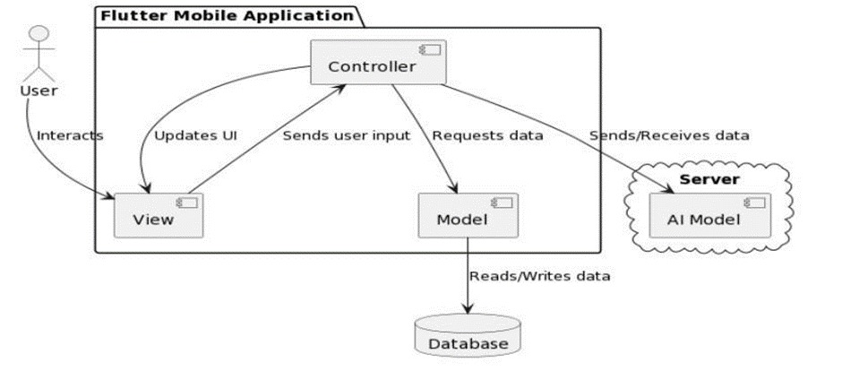

Figure 4.1 System Architecture Diagram

DESCRIPTION:
This diagram illustrates the components and structure of the system, including hardware and software elements. It shows how the different parts of the system interact with each other to achieve its goals.
This diagram would typically show the following components:
• View: Captures user input and sends it to the Controller.
• Controller: Receives data from the View and requests data from the Model.
• Model: Handles data operations and requests AI processing from the AI server.
• AI Server: Processes data with AI models and returns results to the Model.
• Back to Model: Receives processed data from the AI server for further use.
• Update View: The Controller updates the View with the processed data.
The elaboration would detail how these components interact. For instance, it could show how the UI sends requests to the application layer, which retrieves data from the data layer and sends it back to the UI for presentation.
  - Process Flow/Representation

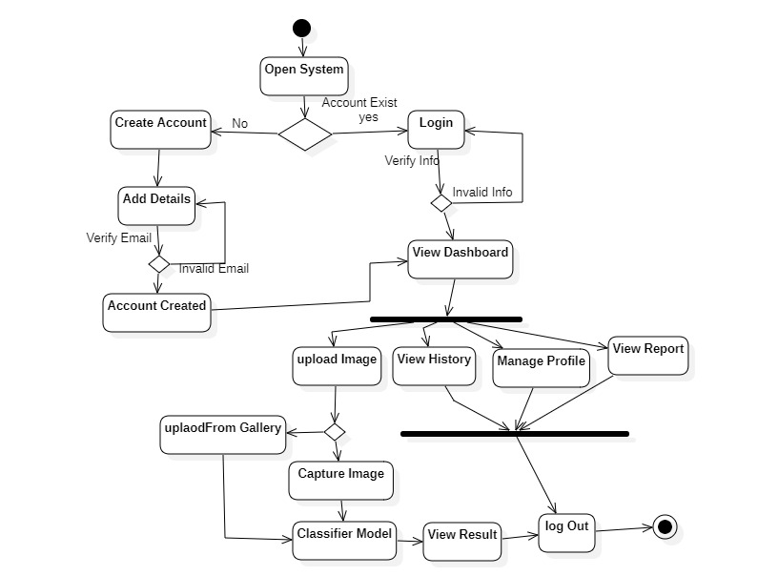
Figure 4.2 Process Flow Representation

DESCRIPTION:
This diagram visually represents the sequence of steps involved in a process within the system. It shows the flow of data and control through the system's components.
- Patient opens the system if account exist it reaches dashboard
- On dashboard patient can view history, view report, and can manage profile,
- In upload patient, can upload image from gallery or can capture image from camera.
- After uploading classifier model classify result and result displays.
- There is a option to view report.
  - Design Models 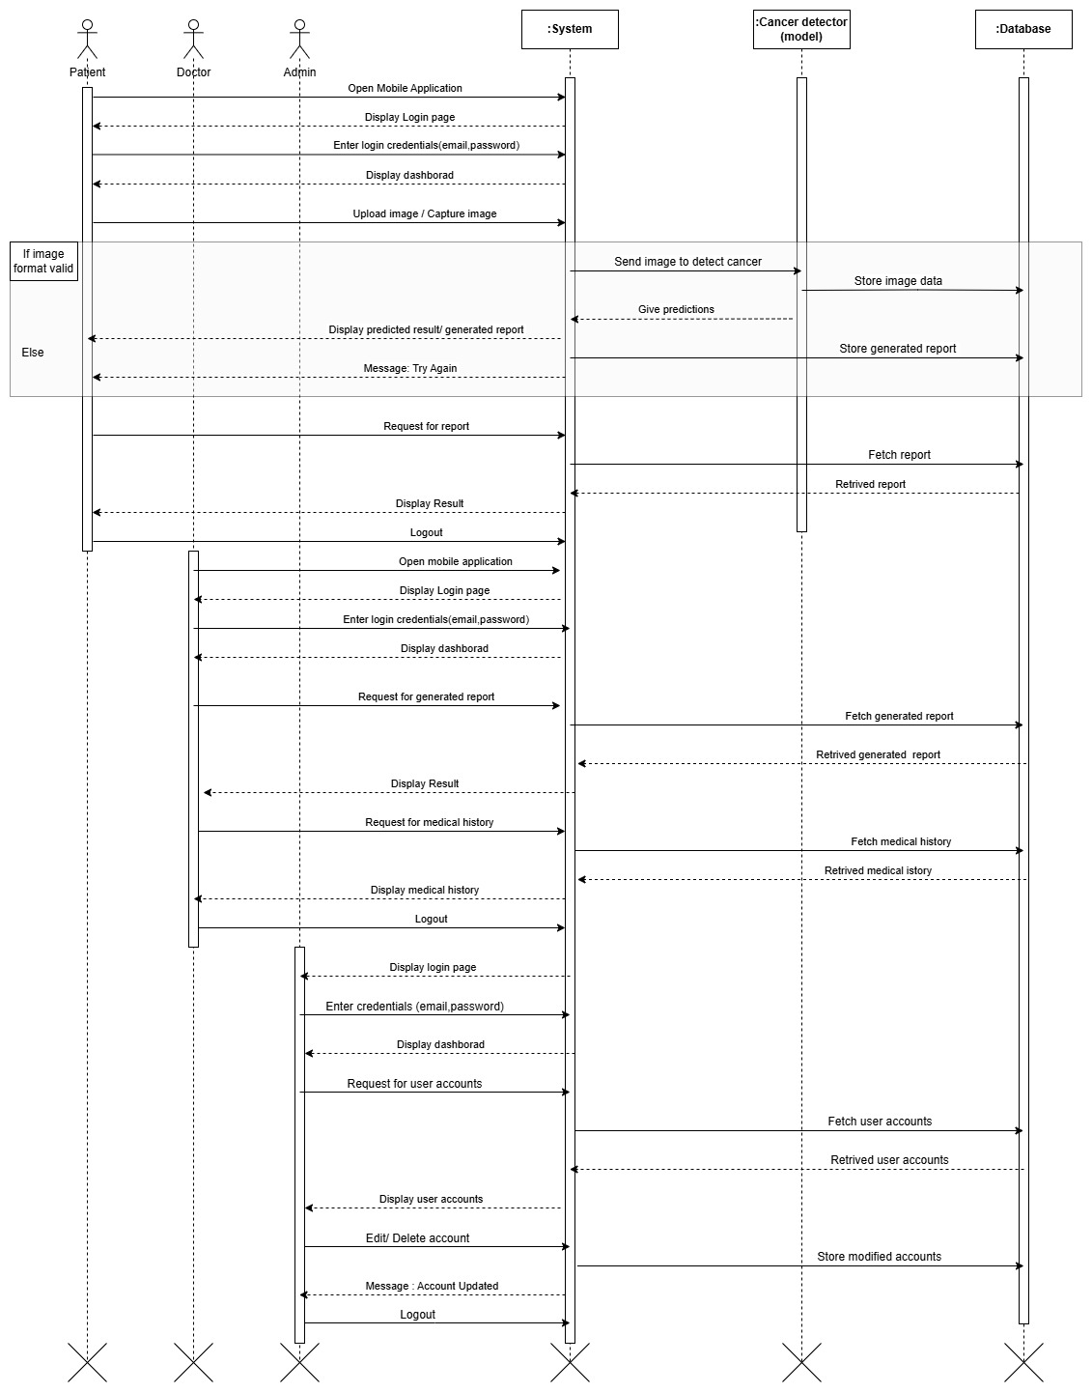
Figure 4.3 Sequence Diagram

DESCRIPTION:
Patient Interaction:
- The patient opens the mobile application, enters their login credentials (email and password), and logs in.
- The patient uploads an image of a suspected cancerous lesion.
- The system processes the uploaded image.
- The system sends the processed image to a cancer detection model, which generates a prediction.
- The system displays the predicted result (e.g., benign or malignant) and a generated report to the patient.
- The patient can request a detailed report.
- The system retrieves the requested report and displays it to the patient.
- The patients log out of the application.

Doctor / Admin Interaction:
- The doctor or admin logs into the system using their credentials.
- The system displays a dashboard, which may include patient data, reports, and system performance.
- The doctor requests to retrieve specific patient’s report.
- The system retrieves and displays the requested report.
- The doctor requests to retrieve the medical history.
- The system retrieves the medical history of the patient.
- The doctor then logs out.
- The admin can manage the account of the user (edit, delete, add).
- The system stores the modified user account.

- Implementation
  - Algorithm

The system’s functionality relies heavily on machine learning algorithms, particularly Convolutional Neural Networks (CNNs), for the detection and classification of skin lesions. The algorithm selected is tailored to the major modules of the system, including lesion detection, classification, and patient record integration. Below is an overview of the algorithms used and a pseudocode representation of the core logic.
Input: Image dataset of skin lesions (labelled as benign or malignant)
Output: Trained CNN model for lesion classification and localization
1. Initialize CNN layers:
a. Input layer (Image size: 224x224, 3 channels - RGB)
b. Convolutional layers with ReLU activation
c. Max Pooling layers to reduce spatial dimensions
d. Fully connected layers
e. Output layer with SoftMax for classification (2 classes: benign, malignant)
2. Preprocess dataset:
a. Normalize image pixel values
b. Augment data (e.g., rotation, flipping) to increase dataset diversity
c. Split data into training, validation, and test sets
3. Train CNN:
a. For each epoch:
- Perform forward pass to compute predictions
- Calculate loss using cross-entropy loss function
- Perform backward pass to compute gradients
- Update weights using an optimizer (e.g., Adam)
4. Validate model on validation set:
a. Compute accuracy, precision, recall, and F1-score
b. Adjust hyper parameters based on validation performance
5. Test final model on test set to evaluate generalization
6. Save the trained model for integration into the mobile application

External APIs
Table 5.1: Details of APIs used in the project
Name of API | Description of API | Purpose of usage | List down the function/class name in which it is used
Rest API | (Representational State Transfer) is an architectural style for designing networked applications. | Chat integration between users. | A class of API is made in which this REST API is used.
Flask API | Its an lightweight, flexible and modular web framework for building web applications and APIs. | To handle image processing and analyzing requests. | It is used in model or used in upload images.
  - User Interface
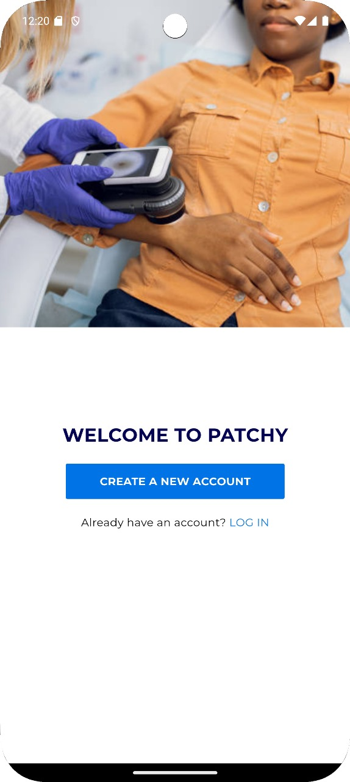
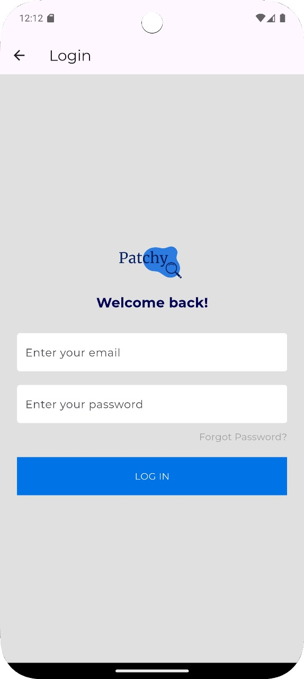

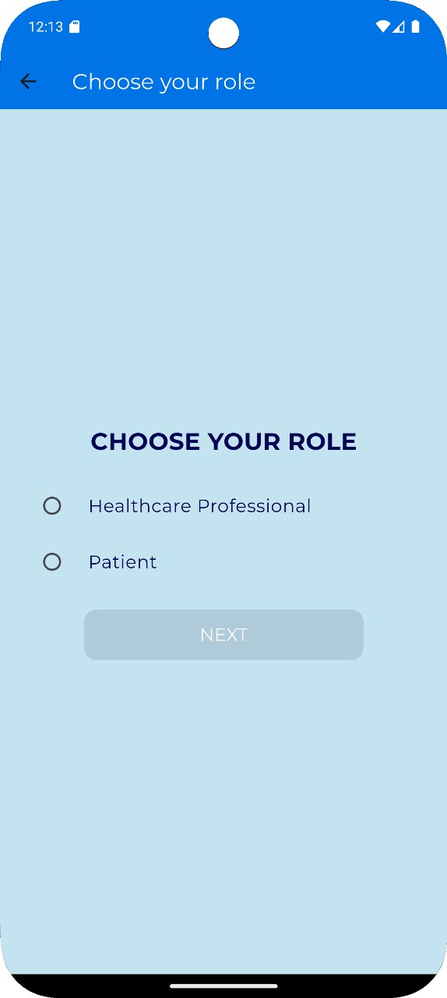

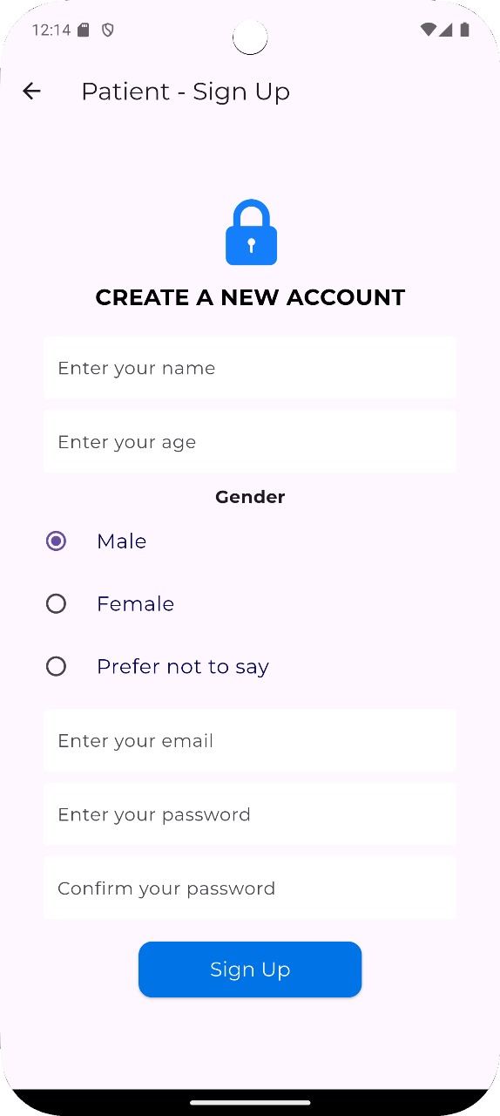

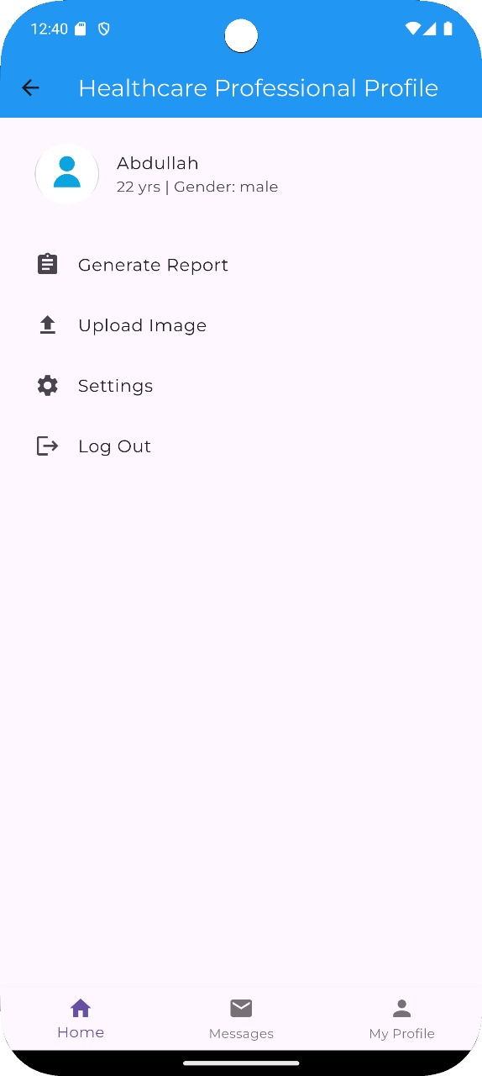

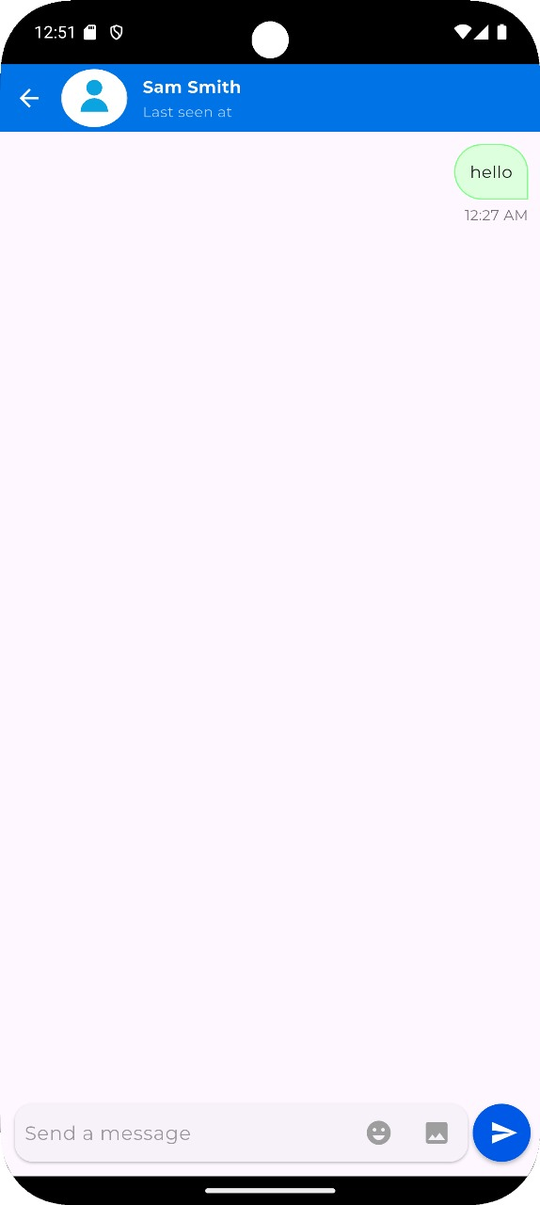

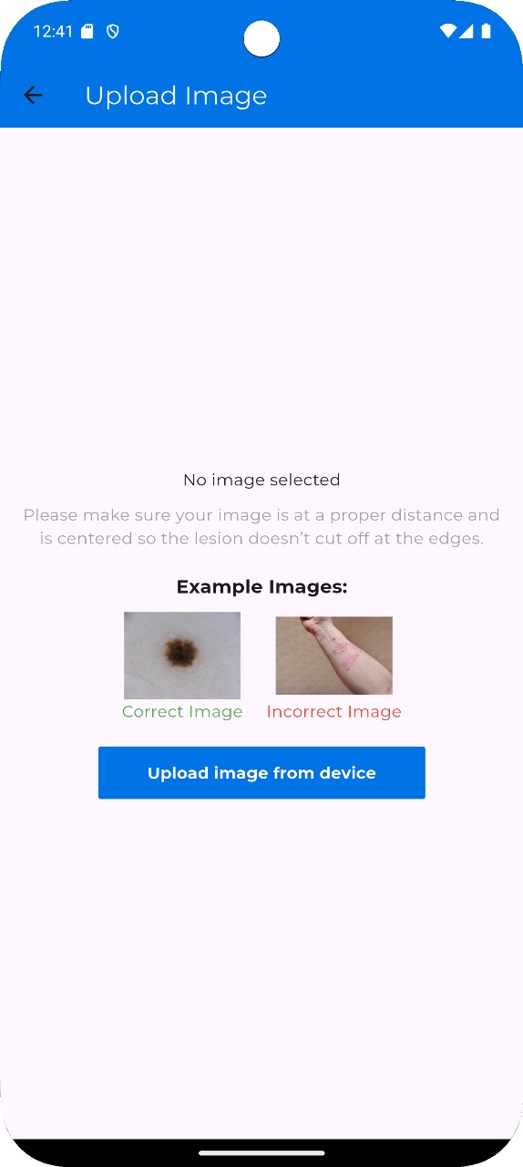

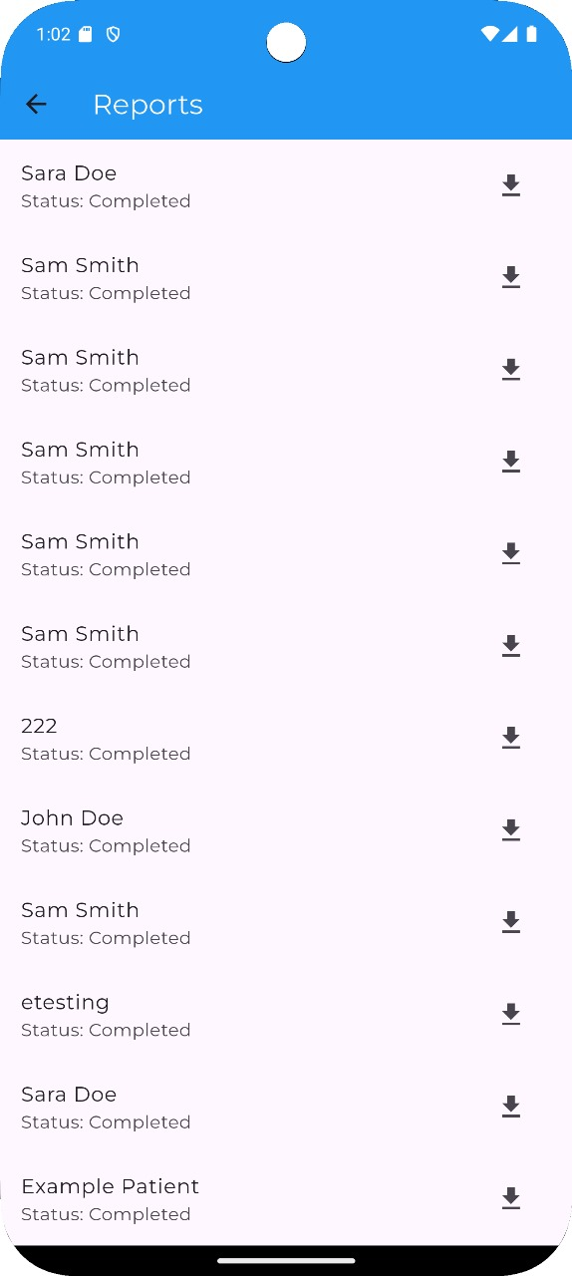

- Testing and Evaluation

  - Manual Testing

    - System testing
Once the system has been successfully developed, testing must be performed to ensure that the system works as intended. This is also to check that the system meets the requirements stated earlier. Besides that, system testing will help in finding the errors that may be hidden from the user. There are few types of testing which includes the unit testing, functional testing and integration testing. The testing must be completed before it is deployed for users to use.
    - Unit Testing
Testing performed once the system has been successfully developed

- Unit Testing 1: Upload Image
Testing Objective: To ensure that it correctly Uploads patient's image and sends image for report generation.
Table 6.1: Upload Image Test case

No. | Test case/Test script | Attribute and value | Expected result | Result
1. | Select Upload image | Click on upload image | The system correctly prompts the user to upload image from gallery. | Pass
2. | Send image for analysis. | Selecting an Image | The system processes the image and sends it for report generation. | pass
3. | Assuming that user uploads correct image | Image is Not Available | System informs the user that to please upload correct image. | pass
4. | Download report from application | Select Patient Report to download | Download is initiated and report is downloaded | pass

- Unit Testing 2: Generate Report
Testing Objective: To ensure the generating of a report based on patient data. The user selects the criteria for the report, and the system compiles the data and generates the report.
Table 6.2: Generate Report Unit Testcase
No. | Test case/Test script | Attribute and value | Expected result | Result
1. | Generate report based on selected criteria | When Image is Uploaded | System generates report based on the CNN model | pass
2. | Download Result | Select download result | System downloads the result to local storage. | pass

- Unit Testing 3: Direct Messaging
Testing Objective: To ensure a user (patient) can interact with other user (Healthcare professional).
Table 6.3: Direct Messaging Unit Testcase
No. | Test case/Test script | Attribute and value | Expected result | Result
1. | Open chat and send a message. | Go to chat interface. | User receives messages correctly. | pass
2. | User can send an image | Selected Image icon. | System prompts the user to upload image | pass

    - Functional Testing
The functional testing will take place after the unit testing. In this functional testing, the functionality of each of the modules is tested. This is to ensure that the system produced meets the specifications and requirements.
- Functional Testing 1: Upload Image as shown in Table 6.4
Objective: To ensure that the image is upload successfully.
Table 6.4: Upload Image Functional Testcase
No. | Test case/Test script | Attribute and value | Expected result | Result
1. | Upload valid image | File format: .jpg, .png | The image is uploaded successfully, and a success message is displayed. | Pass
2. | Upload invalid image | File format: .exe | The upload is rejected, and an error message is displayed: “Invalid file format” | pass

- Functional Testing 2: Generate Report as shown in Table 6.5
Objective: To ensure that the correct report is displayed.
Table 6.5: Generate Report Functional Testcase
No. | Test case/Test script | Attribute and value | Expected result | Result
1. | Validate complete workflow from login to report generation | Uploaded image successfully | User successfully generates and views the report | Pass
2. | Verify report saving functionality | Save the report | User successfully saves the report in the View Result | pass

- Functional Testing 3: Direct Messaging as shown in Table 6.6
Objective: To ensure a user (patient) can interact with other users (Healthcare professionals).
Table 6.6: Direct Messaging Functional Testcase
No. | Test case/Test script | Attribute and value | Expected result | Result
1. | Send a message to a healthcare professional | Sender role: Patient  Receiver role: Healthcare professional  Message: "Hello, I need help with my prescription." | The message is sent successfully, and the receiver gets a notification of the new message. | Pass
2. | Send a message with invalid input | Sender role: Patient  Receiver role: Healthcare professional  Message: (Empty or contains unsupported characters) | The system doesn’t send empty space or empty character. | pass
    - Integration Testing

Table 6.7 shows the integration testing

Table 6.7: Integration Testcase

No. | Test case/Test script | Attribute and value | Expected result | Result
1. | Validate overall system integration when a healthcare professional views image history, checks medical history, and generates reports | Go to image history, check medical history and view report | System performs all operations smoothly without any issues | Pass
2. | Verify user workflow when accessing account information and viewing image history | -Go to Image History | Users can switch between viewing image history and updating account info without issues | Pass
3. | Verify system functionality when generating a report and checking medical history simultaneously | -Uploaded Image and go to Medical History | Reports are generated correctly, and medical history is displayed without issues | Pass
  - Automated Testing:
Automated testing involves using software tools to execute test cases, reducing manual effort and improving accuracy. Below are the tools used for this project:

Tools used:

Table 6.8 shows the tools used in automated testing.
Table 6.8: Tools used
Tool Name | Tool Description | Applied on [list of related tests cases / FR / NFR] | Results
Flutter Test | Built-in testing framework for Flutter apps | Unit tests on widgets, logic, and integration tests | Results vary by test cases
Dart DevTools | Suite of performance and debugging tools for Dart and Flutter | Performance profiling, debugging, and inspecting UI | Results vary by analysis

- Conclusion and Future Work
This project focuses on developing an AI-powered system for early and accurate skin cancer diagnosis. Our goal is to improve dermatological treatment by smoothly integrating AI with medical data. By providing real-time lesion analysis and monitoring, our mobile application enhances clinical processes and decision-making for medical professionals. In the end, this approach improves patient outcomes by enhancing medical knowledge rather than replacing it.

Conclusion
The development of an AI-powered system for the early detection and diagnosis of skin cancer marks a significant advancement in dermatological care. By integrating cutting-edge artificial intelligence with seamless connectivity to medical record systems, our project aims to enhance the accuracy and efficiency of skin lesion diagnosis. The mobile application provides healthcare professionals with a powerful tool for real-time lesion analysis and tracking, ensuring that patients receive timely and accurate diagnoses. This system does not replace the expertise of medical professionals but rather complements it by streamlining clinical workflows and improving decision-making processes. By bridging the gap between technology and clinical expertise, we hope to create a transformative impact on the treatment and management of skin cancer, ultimately leading to better patient outcomes.
  - Future Work
In the future, the AI model's performance and accuracy will be improved, its capabilities will be extended to include lesion segmentation and localization, and the system will be optimized for real-time analysis on mobile devices. The development of an easier-to-use interface, connectivity with tele dermatology platforms, and smooth integration with current healthcare systems will also be priorities. It's also critical to handle ethical issues like model explainability, data privacy, and bias reduction. The potential of cutting-edge technologies like AR/VR, multi-modal data fusion, and continuous learning to enhance the system's functionality and enhance patient outcomes will be investigated in future studies.
- References
- Liu, Y., et al. (2021). "Deep learning-based computer-aided diagnosis for melanoma: A systematic review." Journal of Medical Imaging and Health Informatics, 11(1): 171-187.
- Skin Cancer: HAM10000. (2023, July 5). Retrieved from https://www.kaggle.com/datasets/kmader/skin-cancer-mnist-ham10000
- LeCun, Y., Bengio, Y., & Hinton, G. (2015). "Deep learning." Nature, 521(7553), 436-444.

